**OPTICON OPR-2001Z barcode reader**

Start/Stop character and code identifier transmission configuring for *Codabar* and *Code 128* barcodes

1. Configuring (enabling) the transmission of Start/Stop characters for *Codabar* barcodes:

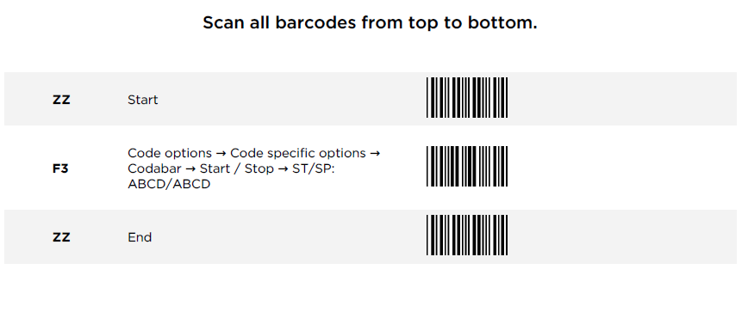

1. Configuring the transmission of the code identifier for *Codabar* and *Code 128* barcodes

(*N* is identifier for *Codabar*, and *K* is identifier for *Code 128*):

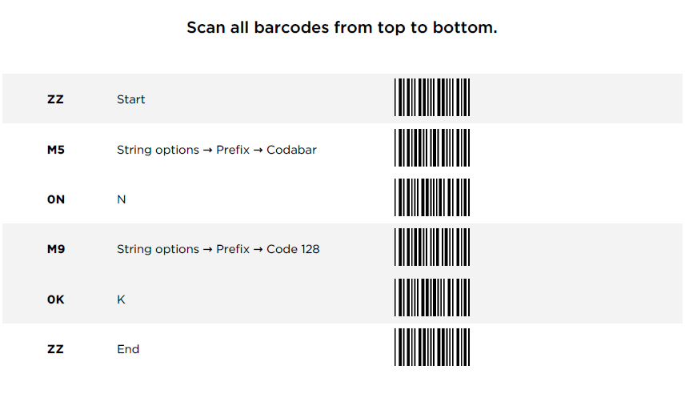

1. Setting the default configuration for the Start/Stop and code identifier transmission for *Codabar* and *Code 128* barcodes:

